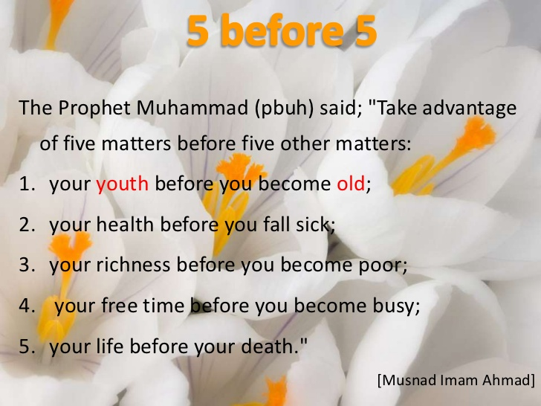
The importance of youth in Islam
Muslim youth can contribute to Islam by giving time, talent, and money. They should also play an important role to bring about positive change in society and should work with an objective of making Islam prevalent over all the other ways of life. The youth is the stage of life when the individual should grasp good knowledge about Islam and make effective utilization of the time and talent given by Allah Almighty.
Youth is the golden period of our life. Our youth is the most important stage of our life because this is the stage when the person chooses a path. The path may be right or wrong. This is the stage; the youth will have many deviations and distractions like watching music, girls, cigarettes, alcohol, games etc. At this age, the parents need to play a very important role in guiding their children to choose the right path so that they are successful in this world and the hereafter and should ensure that they do not adopt the wrong path. Thinking about bringing the children back to a right track after a certain time would be very difficult.
It is true that every journey begins with a single step, but if our first steps have been taken in the wrong direction, then the complete life will be on the wrong path and coming on the right path will become very difficult. Some youth think that this is the time to enjoy and once they come out of college they will adopt the right track but they do not know that coming back to the right part will become next to impossible.
Our youngster of Islam: just think deeply about your responsibilities being Muslim being bright future of this beautiful religion. Just imagine how much blessings Allah has given to you. One of these blessings of Allah Almighty is youth. you are young, you need to be part of your Deen, you need to take responsibility to spread Islam in the all community and the entire world, and convey the message of Allah Almighty and his beloved messenger(peace be upon him) to the people.
Prophet Muhammad (peace and mercy of Allah be upon him) has listed seven kinds of people who will be sheltered under the shade of God on the Day of Judgment. And from among those fortunate people one is that young man who passed his youth in the worship and the service of god.
From this hadith we can easily understand the importance given to youth by Prophet Muhammad (peace and mercy of Allah constantly be upon him). This is the stage when the Satan easily gains control over the person and leads him to the wrong path. So, in this stage the person should be over conscious on the various activities done by him. If We just give the Satan an inch and he will rule over us.
Three common areas where Muslim youth should focus are as follows:
1. Obeying and respecting our parents.
2. Effective utilization of time (avoid wasting time).
3. Avoid seeing, and listening to, something which is prohibited by Islam.
In our youth, most of us think that we know everything; some also think that they know more than their parents. Due to this type of attitude they tend to disobey their parents. The children might gain more knowledge in a particular field but, in terms of experience, they can never beat their parents. Considering our parents more knowledgeable and experienced than us will help us to obey and respect them.
Today’s youth should be the “Youth with a mission” – a mission to contribute for Islam. A youth can contribute to Islam by giving his time, talent, and money. A youth should also play an important role to bring about a drastic change in society. The youth should work with an objective of making Islam prevalent over all the other ways of life. The youth is the stage of life when the individual should grasp good knowledge about Islam and make effective utilization of the time and talent given by Allah Almighty.
We all should remember that all that we have today is only given by Allah Almighty and every single thing belongs to him, thus we should spend everything and do every possible thing for the sake of Allah with a sole objective to please Him.
The Muslim youth are the future Islamic leaders, so it is very important for the youth to understand Islam in the right perspective by gaining the correct knowledge of Islam from the Qur’an and the authentic Sunnah and understand the real purpose of existence on this earth.
The youth is the “make it” or “break it” stage of our life. May Allah Almighty help the Muslim youth to follow Islam completely and correctly

By: Maulana Azmatullah Najmi
Imam Jamia Mosque Newport UK
MOB: 07878751065

